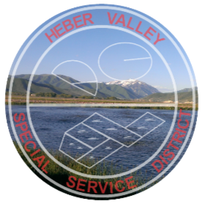
Heber Valley Special Service District
Contact Name: Janet Carson
Phone: 435-671-2497
Email: jcarson@hvssd.org
Press Release: March 7, 2024

HVSSD Health and Safety Concerns
Heber Valley SSD is committed to the health and safety of our community as we provide essential water treatment services to the Heber Valley. We have appreciated the input from neighbors of our wastewater treatment plant reporting odor concerns. Since these concerns began last year, investigation of reports and mitigation of any odors coming from the treatment plant has been our top priority. In collaboration with our partners at Midway Sanitation District (MSD), we have taken several steps to investigate and address these concerns.
• Community Engagement. In July 2023, we launched a dedicated section of our website to keep the community informed about our investigation of odor complaints and odor mitigation efforts. Updates can be found at https://Sewer District.org/odor-updates.

• Open Dialogue. We have conducted multiple public meetings allowing residents an opportunity to voice their concerns, including the meeting in conjunction with the Wasatch County Health Department and the State of Utah Department of Health and Human Services, DHHS, on February 27, 2024. These meetings have been important opportunities for us to hear from residents and have a transparent process for responding to their concerns.

• Health and Safety Assessments. We have always been committed to maintaining safe water and air quality at our facility and have consistently met established safety standards. In special response to the current community concerns, we have requested DHHS test water and air quality to assess any potential health concerns. In response to that request, the DHHS Environmental Epidemiology Program will conduct a community health assessment to sample the water and air at our treatment facility. They have established a website for collecting odor reports. https://appletree.utah.gov/heber-valley-special-services-district/

• Expert Consulting. In July of 2023, we engaged Environment Resources Group (ERG), a nationally recognized leader in wastewater treatment with special expertise in odor mitigation, to conduct a study of our wastewater lagoons and recommend methods to mitigate odor.

• Infrastructure Improvements. In September 2023, MSD, which owns and manages the sewer collection lines in the area where odor concerns have been coming, hired a contractor to clean the collection lines and update manhole covers from vented covers to solid covers.

• Treatment System Installation. Following ERG’s recommendations, we have purchased and implemented hydrogen peroxide and calcium nitrate solution dosing systems designed to significantly reduce odor in the HVSSD treatment lagoons. We are excited to begin use of this system this week ahead of spring turnover.

As we implement these improvements and continue to work with our neighbors and partners, we are optimistic about the positive impact these updates will have on our community.

